H.T No
Regulations:
A17

Sreenidhi Institute of Science and Technology
(An Autonomous Institution)
Code No: 6AC07 Date: 14-Aug-2023 (FN)

B.Tech II-Year II- Semester External Examination, Aug - 2023 (Supplementary)
CONTROL SYSTEMS (EEE)

Time: 3 Hours Max.Marks:75

Note: a) No additional answer sheets will be provided.
b) All sub-parts of a question must be answered at one place only, otherwise it will not be valued.
c) Missing data can be assumed suitably.

Bloom's Cognitive Levels of Learning (BCLL)

Remember | L1 | Apply | L3 | Evaluate | L5
Understand | L2 | Analyze | L4 | Create | L6

Part - A Max.Marks:25
Answer all QUESTIONS

 |  | BCLL | CO(s) | Marks
1 | Write the Manson’s gain formula. | L4 | CO1 | [2M]
2 | Explain how feedback effects overall gain of the system. | L1 | CO2 | [2M]
3 | What are the standard test signals used in control systems? | L2 | CO3 | [2M]
4 | What are frequency domain specifications? | L4 | CO4 | [2M]
5 | What is polar plot? | L5 | CO5 | [2M]
6 | What is state diagram? | L1 | CO6 | [3M]
7 | What are the effects negative feedback systems. | L2 | CO2 | [3M]
8 | Define gain margin and phase margin. | L3 | CO3 | [3M]
9 | Explain the basics of root locus plot. | L1 | CO5 | [3M]
10 | What is the effect on polar plot if a pole is added to the transfer function? | L2 | CO5 | [3M]
Part – B Max.Marks:50
ANSWER ANY FIVE QUESTIONS. EACH QUESTION CARRIES 10 MARKS.

 |  |  | BCLL | CO(s) | Marks
11. |  | For the system represented by the block diagram shown in figure 1. Find C(s) / R(s)  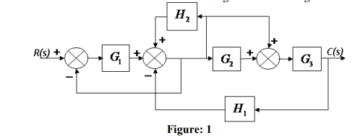 | L3 | CO1 | [10M]
12. | a) | Write the equations for time domain specifications of a standard second order system with unit step input. | L3 | CO2 | [5M]
 | b) | Explain the effect of Proportional control action on the performance of a second order system. | L4 | CO2 | [5M]
13. |  | A unity feedback system has an open loop function  G (s) = 𝑘/ 𝑠 (𝑠²+ 4𝑠+13) make a rough sketch of root locus plot by determining the following (i) Centroid  (ii) number and angle of asymptotes  (iii) angle of departure of root loci from the poles  (iv) Breakaway points if any. | L5 | CO3 | [10M]
14. |  | Given 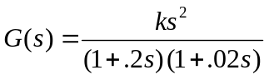  Find K so that the system is stable for gain margin equal to 28. | L5 | CO4 | [10M]
15. | a) | The open-loop transfer function of a system is given by  G(s)= K / s(1+0.1s) (1+0.2s). Draw the polar plot. | L6 | CO5 | [5M]
 | b) | Write the Nyquist Stability criterion and discuss the method to obtain stability using it. | L3 | CO5 | [5M]
16. | a) | Distinguish between Transfer function model and State Space model. | L2 | CO6 | [5M]
 | b) | List out the properties of state transtion matrix in state space analysis. | L4 | CO6 | [5M]
17. | a) | Give the difference between open loop and closed loop system. | L1 | CO1 | [4M]
 | b) | The open-loop transfer function of a unity feedback control system is given by G(s) = 9/ s (s+3). Find the natural frequency of response, damping ratio. | L3 | CO2 | [3M]
 | c) | Determine the RH stability of given characteristic equation,  s⁴ + 8s³ + 18s² + 16s + 5 = 0 | L4 | CO3 | [3M]
18. | a) | Outline the Bode plot for a Proportional Integral controller | L2 | CO4 | [4M]
 | b) | Draw the polar plot for 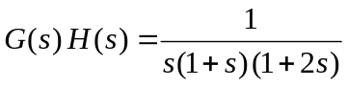 | L4 | CO5 | [3M]
 | c) | Obtain the state space representation of an nth order differential equation. | L1 | CO6 | [3M]

-- 00 -- 00 –

